Passes Users Guide
Installation:
To Install go to MAXScript>Run Script and choose the passes script. You might have to run it twice. You should now have a new item called passes at the bottom of your rendering menu.
Matte Pass:
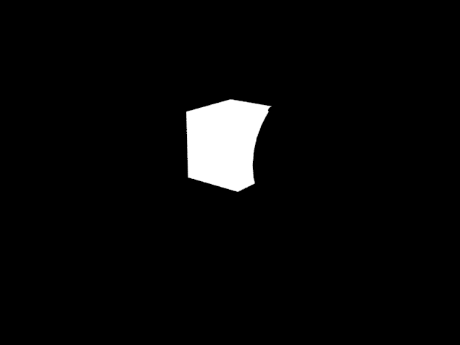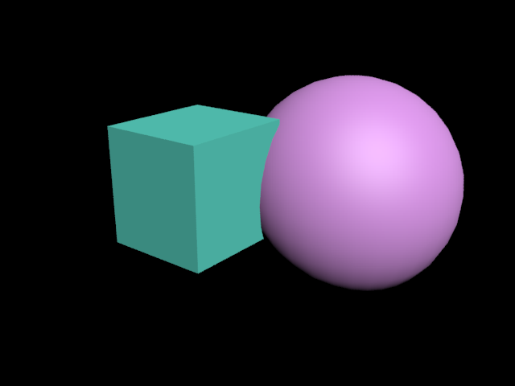
This is a matte of the box were we see the rest of the scene is rendered black.
The object or objects that are added the list box will be rendered pure white while all the other objects that are in the scene and visable to camera will be rendered black. It works great when used as a track matte in after effects.
Add is a pickbutton that allows you pick objects to your scene that you what to add to the matte. Use Selection will add all the objects from a selection of objects. Remove will remove objects from the matte.
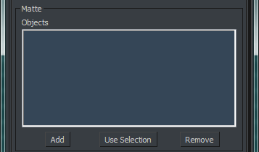

Ambient Occlusion Pass:
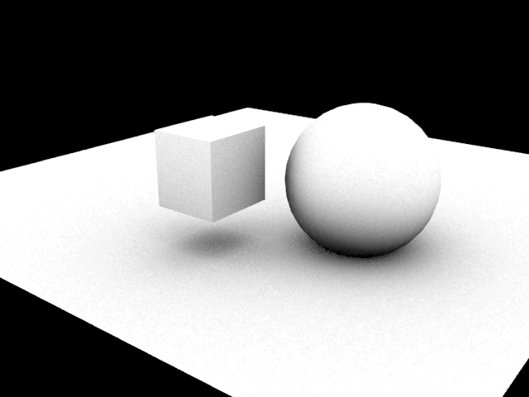
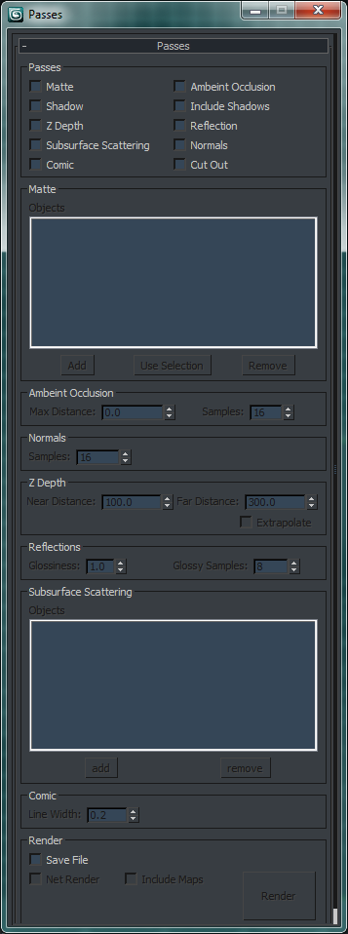
Renders Ambient Occlusion for all objects that are visable to camera. It will use bump maps for most materials. It will not support Displacement yet.
Samples: is the number of probe rays that will be sent. More rays yield a smoother image. Occlusion mapping will never be as smooth as well-tuned final gathering or photons, but is computationally cheap.
Max Distance: is the range within which geometry is probed. If it is zero, the entire scene is sampled. If it is a nonzero value, only objects within this distance will be considered (which makes sampling much faster) where objects outside this range do not occlude at all and objects that are closer occlude more strongly as the distance approaches zero.
Normal’s Pass:
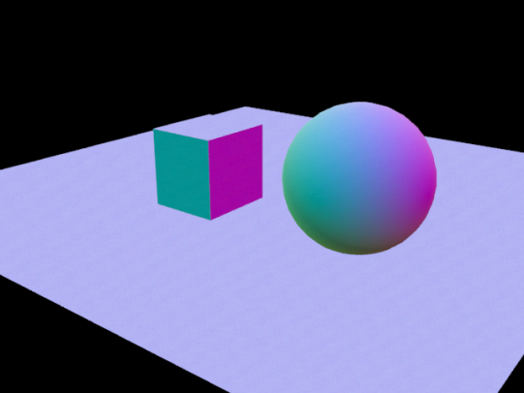
Renders the normals for all objects that are visable to camera. It will use bump maps for most materials. It will not support Displacement yet.
Samples: is the number of probe rays that will be sent. More rays yield a smoother image. Occlusion mapping will never be as smooth as well-tuned final gathering or photons, but is computationally cheap.
Cut Out:
Cut out will cut out objects set to NOT be visible to camera from any objects that are visible to camera.
Sphere cutout from the square
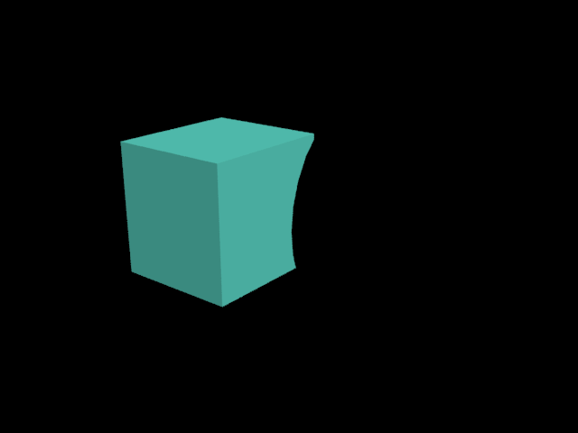
The alpha channel of the cutout pass
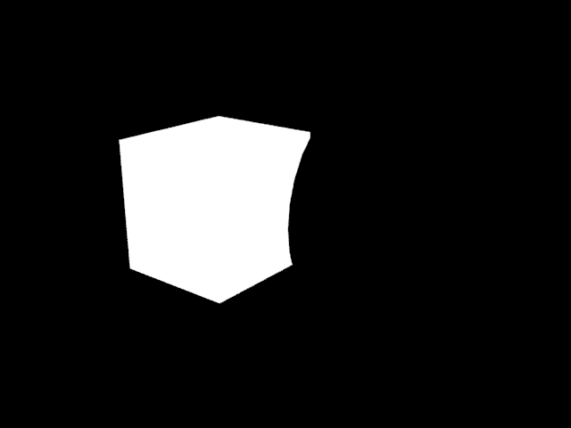
Original image
Shadows Pass:
This can be used to render an object with its correct reflections plus the shadows from the scene. It certain situations it will even render just the shadows from a scene.
Include Shadow’s Pass:
This applies a matte shadow reflection material to all objects visible to camera. So if you want an object to cast a shadow you turn off its visibility to camera and use this and it will render a shadow pass for that object.
Z Depth Pass:
Renders the depth in a scene.
Near Distance: The minimum distance to include in the Z-depth rendering. The area that will be rendered white. This is a value in 3ds Max units, and cannot be less than 0.0. Default=100.0
Far Distance: The maximum distance to include in the Z-depth rendering. The area that will be rendered black. This is a value in 3ds Max units. Default=300.0
Reflection Pass:
Right now it renders pretty close to mirror reflections. Which means you will need to adjust for that it in post if your objects are not mirrors.
Glossiness: The glossiness of reflections. Glossy Samples: The number of glossy-reflection samples.

Subsurface Scattering Pass:
This Separates the material of the object that is added to the list box in to a backsurface, Epidermal, Subdermal, Unscattered and Specular pass. Right now it will only use the SSS fast skin material.

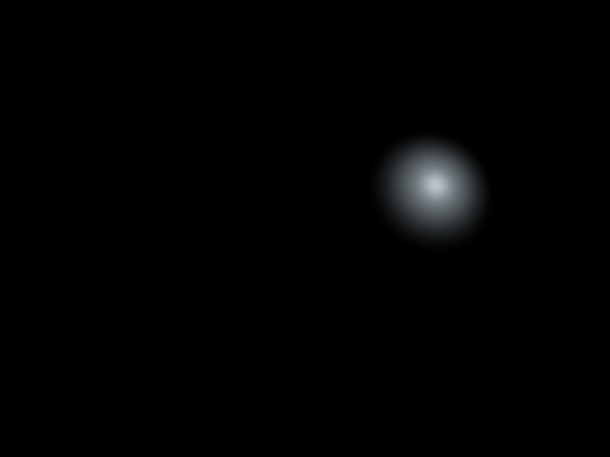
Specular
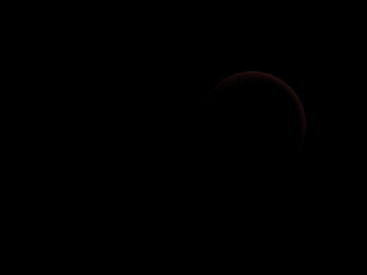
Backsurface
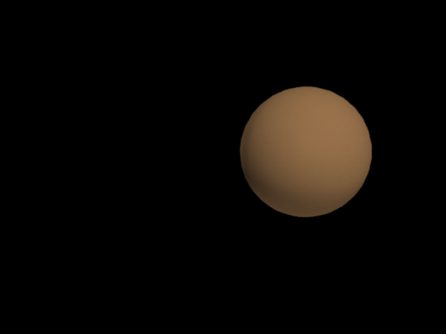
Subdermal
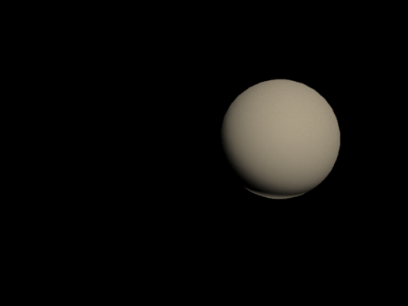
Epidermal

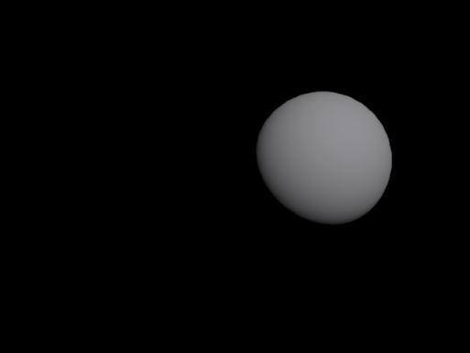
Unscattered

Comic pass:
This renders a black and white line drawing version of your scene. I like to use this for story boarding.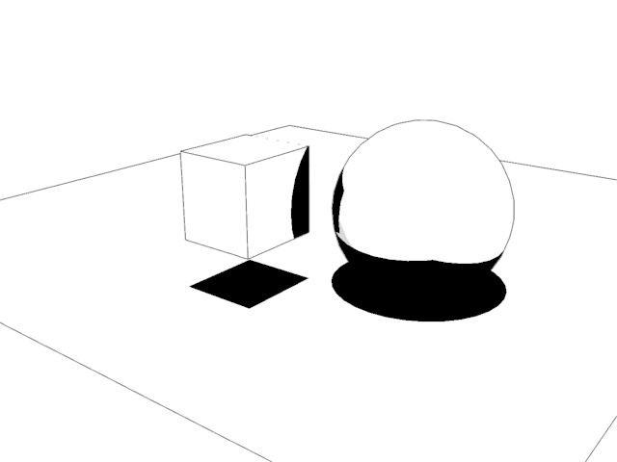
Render:
Save: If this is checked it will save an image to the directory listed in your render output rollout of your render settings but in a new folder named after the pass so you’re Directory/PassName and the name will be OriginaName_PassName. If it’s not checked no image will be saved.
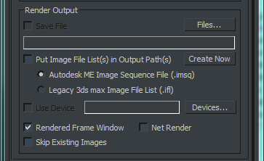
Net Render: Will silently submit your passes to the render farm. Meaning there is no dialog. Include Maps: will include you maps in the package that is sent to the render farm.

